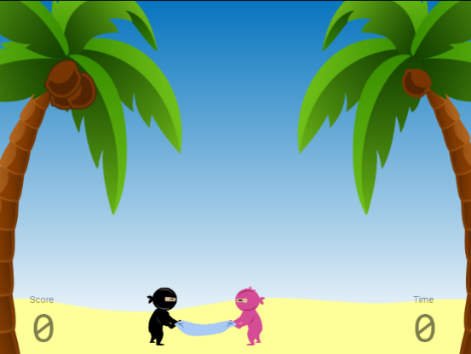

Rajid made great progress today!

We worked on a project called Coconut Chaos! Rajid had to use conditionals and if statements to move an object when a key is pressed. To do this he had to use Functions and Parameters, If Statements, Object Names, and Pseudocode! All things we have been practising through White Belt so far.

Rajid also accomplished these goals set by the National Curriculum in England: Computing Programmes of Study - Key Stage 2.1: Design, write and debug programs that accomplish specific goals. Key Stage 3.4: Understand simple Boolean logic.

We also split up the session to have some focus and fun with some block-based programming with our Sphero robot. Rajid loved these!

In our next session we will be learning how to create a more advanced movement scheme and how to make a scoring system. With these foundational features he is making good strides in game development.

I look forward to seeing his amazing focus next week!

~ Sensei Dereece

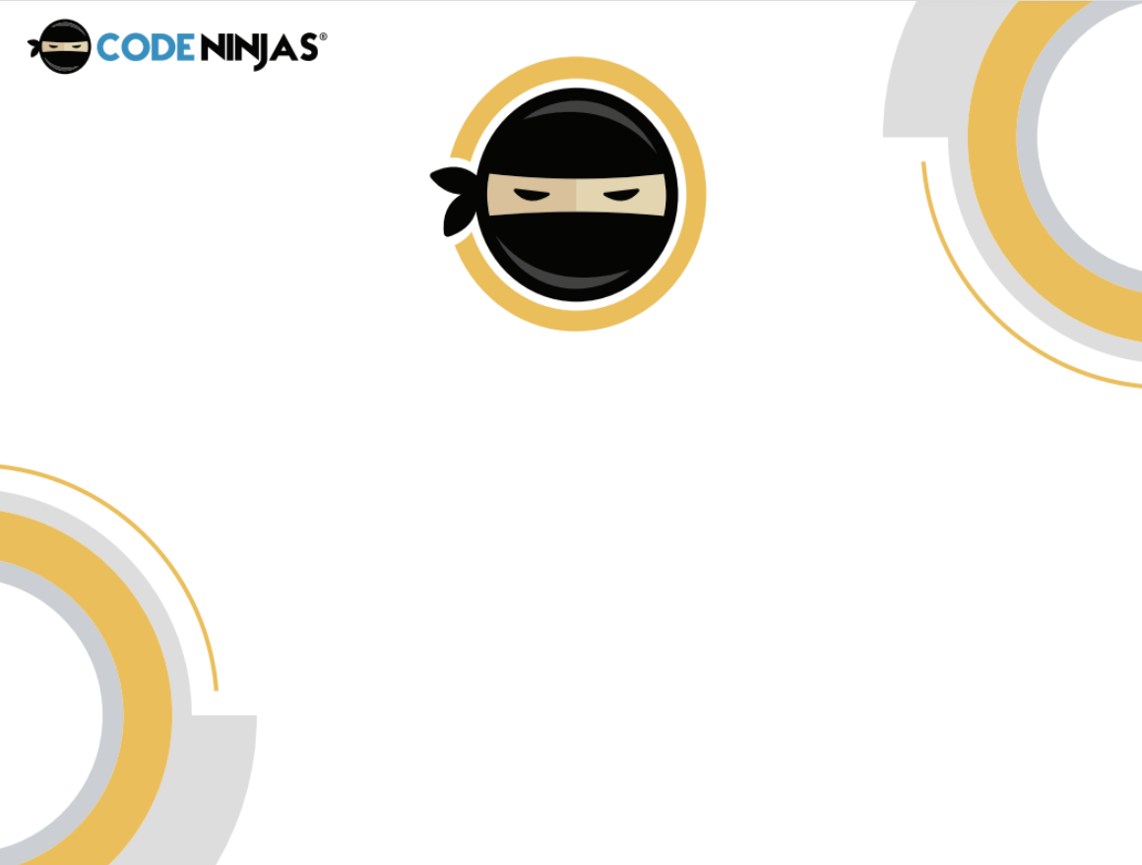

Jonny was awesome today!

Jonny continued his journey on our first huge Yellow Belt project, Rain Catcher!

In the third part of this activity, Jonny learned how to make the raindrops fall randomly. The purpose of this lesson is to create rain drops at a random time now that the cloud is no longer in the scene. Implementing randomness is an integral function to a lot of IOS & Android app store games, so getting to grips with it now is hugely beneficial.

Jonny demonstrated a huge amount of focus today which I way very proud of. This initial step up into more complex ideas can feel overwhelming at first until we work more together and gain confidence with these concepts. Having said that he is taking the new challenges in his stride!

In the next and fourth part of Rain Catcher, Jonny will be working on how to add a powerup into our project. He already has a few cool custom ideas!

I cannot wait to continue the Rain Catcher project with him next week!

~ Sensei Dereece

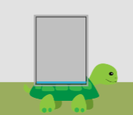



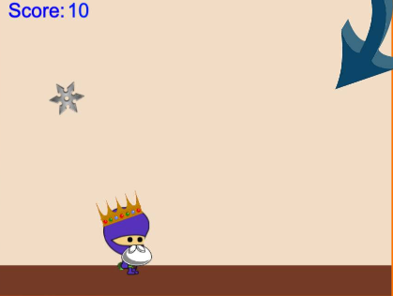

Well done to Alexander!

Today he worked on a project called ‘Shuriken Dodge’, essentially the objective of the game is to see how long players can last without being hit. Alexander learned how to increase score as a function of time passing, and how to increase the difficulty in a game as time passes.

He achieved this by making the speed ramp up by 1.5 times after 3 shuriken had been thrown. Implementing such tactics can be an integral feature to a lot of IOS & Android app store games, so getting to grips with it now is hugely beneficial. Bearing this in mind, in the next session Alexander will be tackling the concept of parallax scrolling, which is yet another popular game design feature, so popular that by now it could be considered its own genre!

Alexander seemed to have had a great time with him cracking his usual jokes and I am impressed with his progress thus far in Orange Belt. Asking when he can play with some scratch with only 10 minutes to go this time, I don’t even think he realised how time had flown completing this game!

Hopefully we get to see Alexander and yourselves again soon.

~ Sensei Chris



Well done to Markus!

Today he worked on a project called ‘Dojo Practice’, this essentially involves creating a sequence to click on the targets in the right order. If you match them, the sequence becomes progressively longer and thus the memory game is harder.

It is conceptually similar to Simon Says, and it requires an understanding of how arrays work to store and extract data. Arrays are a new concept that Markus has just starting to work with.

This project is quite large compared to ones that came before it, so we had to spend a lot of time to truly understand the foundations. We coupled this technical session with practising some robotics coding with our brand new STEM projects.

Markus had a great time and I am impressed with his progress. Next session we will be trying to fix a debug with our dummy sequence so that everything will work smoothly.

I cannot wait to see what Markus implements into his game next week!

~ Sensei Dereece